Site Selection for Wind Output Data
Outside the EU, Renewables.ninja does not offer pre-aggregated national wind-output (capacity-factor) time series for download — those bulk "country" datasets exist only for European countries. For the rest of the world, including China and South Korea, only point (single lat/lon) simulations are available, through the token-authenticated API.
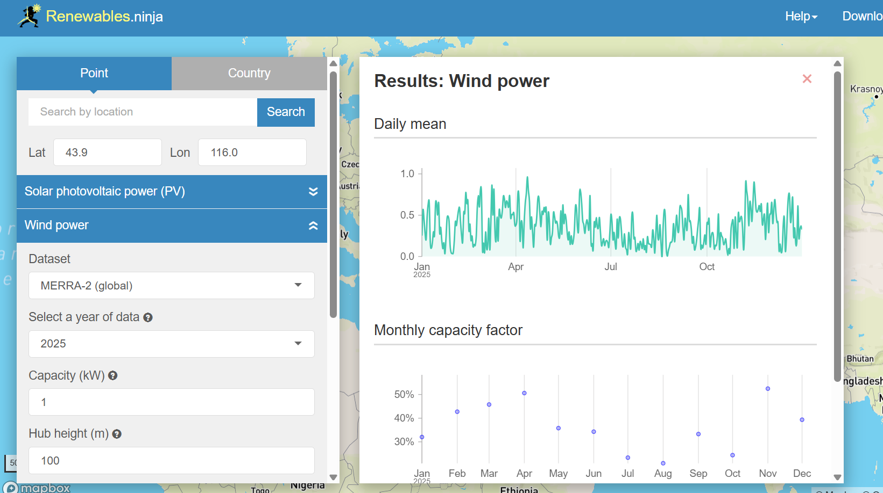
Figure 1 Example Manual Wind Power Output Call
Reproducing the Staffell & Pfenninger (2016) "Virtual Wind Farm" methodology ourselves at national scale would mean simulating every reanalysis grid cell, weighting by the actual turbine-fleet distribution, and bias-correcting against metered national output — data- and compute-intensive work that Renewables.ninja has already performed. It is far more efficient to reuse its already-computed point outputs at representative locations.
Therefore, for wind we stopped translating the 2 m wind speed to a capacity factor. The 2 m MERRA-2 wind field (U2M/V2M) has a diurnal cycle that is inverted relative to turbine hub height — it peaks mid-afternoon instead of overnight — so no vertical extrapolation recovers the correct time-of-day shape. Instead we read the Renewables.ninja wind simulation output for hand-picked sites in each country's main wind regions (hub-height, power-curve, bias-corrected; fetched with capacity = 1 so the electricity column is the hourly capacity factor) and average across sites/years. The script for the API download is in \Global-Electricity-File-Creator\scripts\fetch_ninja_sites.py and the user can specify what locations to include. User should create their own Renewables.ninja login to allow for 50 downloads per hour. User must update the API token.
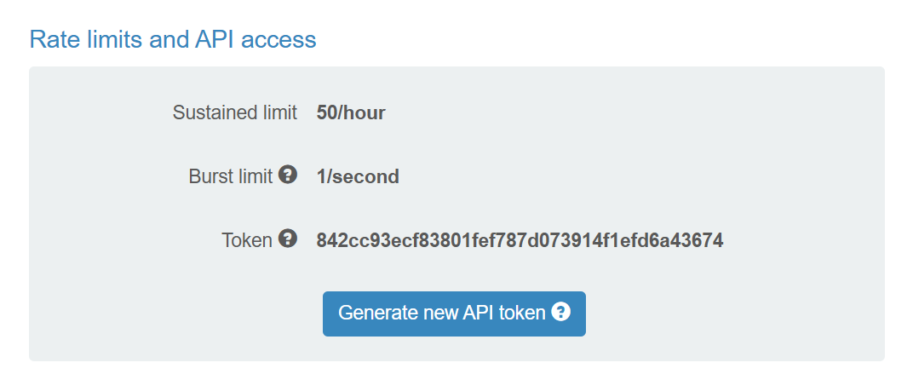
Figure 2 Example API token found under user profile. This gets saved in data/.ninja_token
The point locations were hand-picked to sit in each country's principal wind-generation regions — for China, the major northern onshore wind bases (Inner Mongolia, Gansu, Xinjiang, Hebei, Jilin, Ningxia) plus the main coastal offshore clusters (Jiangsu, Guangdong, Fujian), and for South Korea, the Gangwon onshore ridge, Jeju, and the southwest/southeast offshore development zones.

Real Wind Turbines in China
Source: https://www.bakerinstitute.org/map-chinas-energy-infrastructure
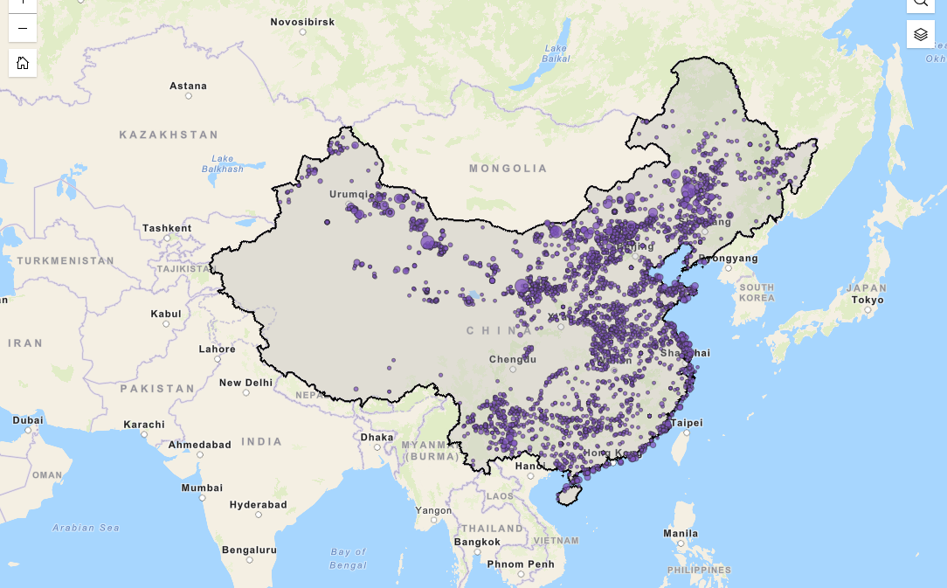
Representative Sites from Renewables.Ninja in China
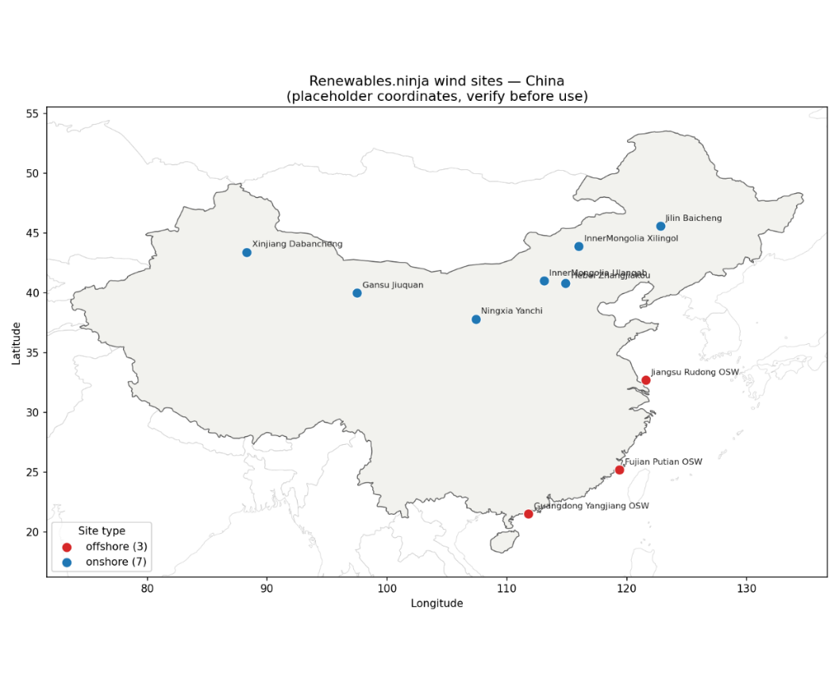

Real Wind Turbines in South Korea
Source: http://nationalatlas.ngii.go.kr/pages/page_2390.php
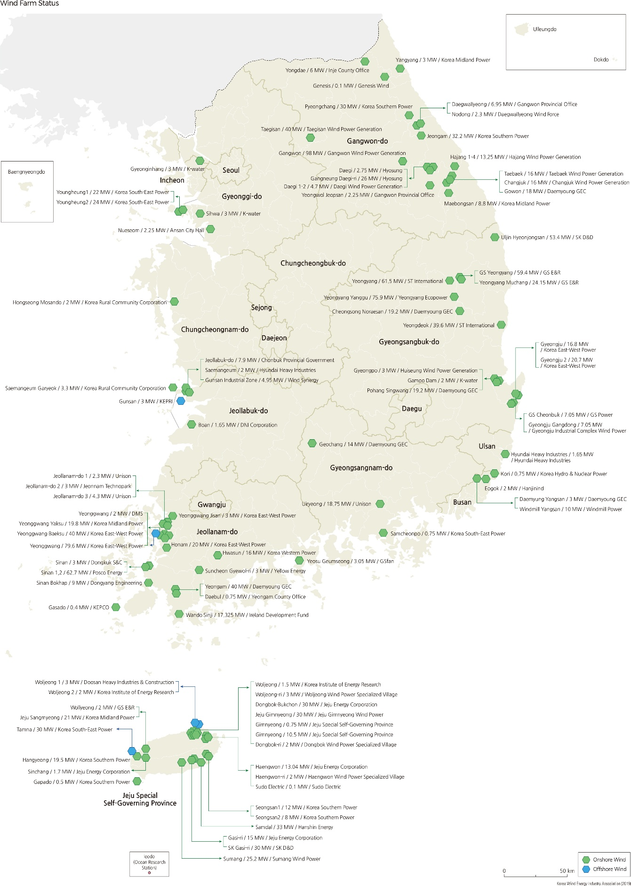
Representative Sites from Renewables.Ninja in South Korea

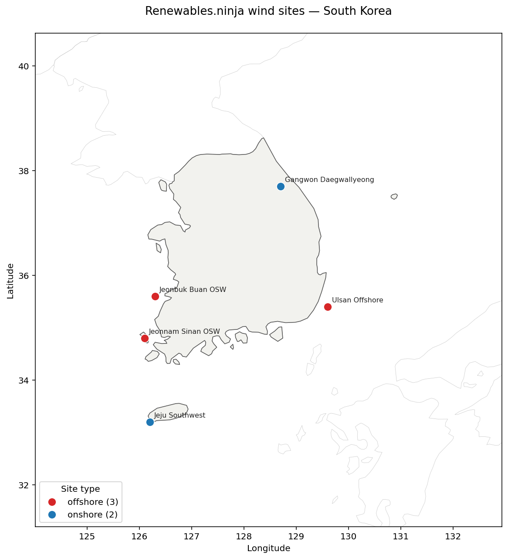

https://www.sciencedirect.com/science/article/pii/S0360544216311811

